**PRAKTIKUM 13**

**KONEKSI DATABASE DENGAN R SHINY**

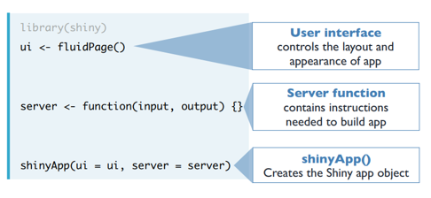

Gambar Anatomy dari shiny app

(Sumber : https://s3.amazonaws.com/assets.datacamp.com)

Dataset : houseprices

|  |
| --- |
| library("RMySQL")  library("readxl")  library(shiny)  con <- dbConnect(RMySQL::MySQL(), host = "localhost",dbname="houseprices",user = "root", password = "")  # Define UI for application  yy <- fluidPage(  titlePanel("Analisis Houseprices"),  sidebarLayout(  sidebarPanel(  selectInput("hprice", "Pilih:",  choices = c("Price", "SqFt",  "Bedrooms", "Bathrooms",  "Offers", "Brick",  "Neighborhood"))        ),  mainPanel(  plotOutput('contents')  )  )  )  hh <- function(input, output) {  output$contents <- renderPlot({    # input$file1 will be NULL initially. After the user selects  # and uploads a file, it will be a data frame with 'name',  # 'size', 'type', and 'datapath' columns. The 'datapath'  # column will contain the local filenames where the data can  # be found.    inFile <- input$hprice    if (is.null(inFile))  return(NULL)      myQuery2 <- "select * from `table 2`"  dff <- dbGetQuery(con, myQuery2)    select = input$hprice    if(select=="Price"){  boxplot(dff$Price)  }else if(select=="SqFt"){  boxplot(dff$SqFt)  }  else if(select=="Bedrooms"){  boxplot(dff$Price~dff$Bedrooms)  }  else if(select=="Bathrooms"){  boxplot(dff$Price~dff$Bathrooms)  }  else if(select=="Offers"){  boxplot(dff$Price~dff$Offers)  }  else if(select=="Brick"){  boxplot(dff$Price~dff$Brick)  }  else if(select=="Neighborhood"){  boxplot(dff$Price~dff$Neighborhood)  }    })  }  shinyApp(ui = yy, server=hh) |

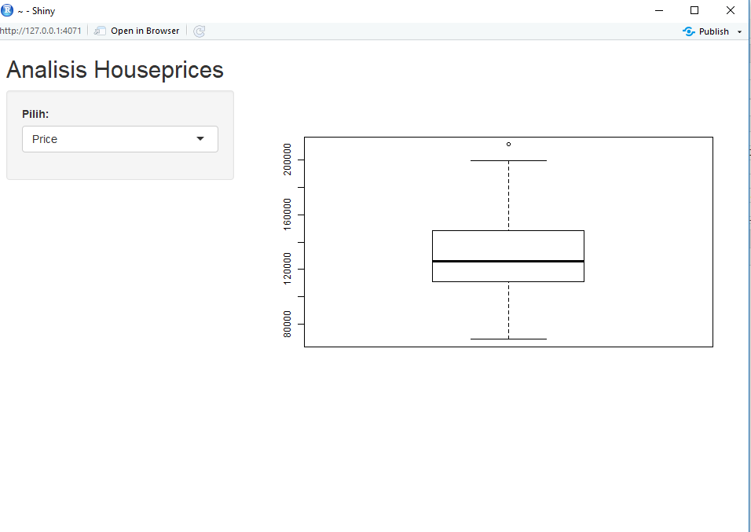

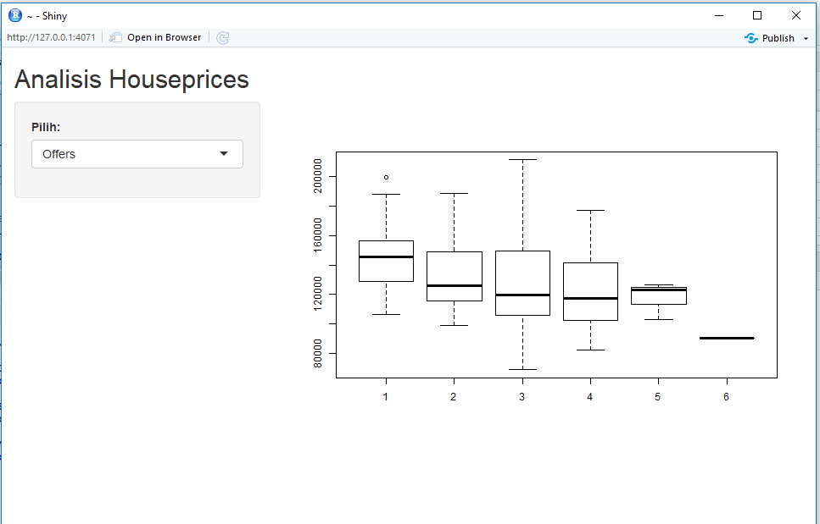

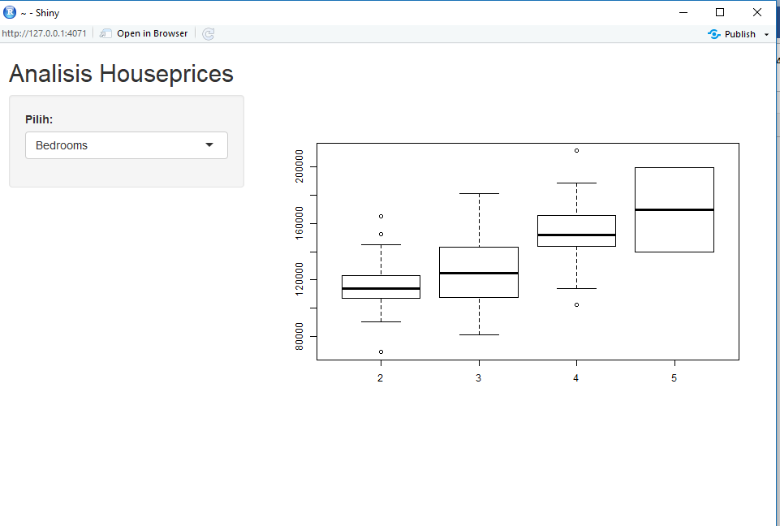

Dataset : komoditas.csv

|  |
| --- |
| library(shiny)  library(factoextra)  library(NbClust)  # Define UI for application  hm <- fluidPage(  titlePanel("K-Means Cluster"),  sidebarLayout(  sidebarPanel(  fileInput('file1', 'Pilih File CSV',  accept=c('text/csv',  'text/comma-separated-values,text/plain',  '.csv')),  tags$hr()  ),  mainPanel(  plotOutput('contents')  )  )  )  ya <- function(input, output) {  output$contents <- renderPlot({    # input$file1 will be NULL initially. After the user selects  # and uploads a file, it will be a data frame with 'name',  # 'size', 'type', and 'datapath' columns. The 'datapath'  # column will contain the local filenames where the data can  # be found.  inFile <- input$file1  if (is.null(inFile))  return(NULL)    dataku <- read.csv(inFile$datapath)  kmeanswilda=dataku[,2:6]    nb <- NbClust(kmeanswilda, distance = "euclidean", min.nc =2, max.nc = 10,  method = "complete", index ="all")  km.res=kmeans(kmeanswilda,3,nstart = 25)  fviz_cluster(km.res, data = kmeanswilda, geom = "point",stand = FALSE, frame.type = "norm")  fviz_cluster(km.res, data = kmeanswilda)  })  }  shinyApp(ui = hm, server=ya) |

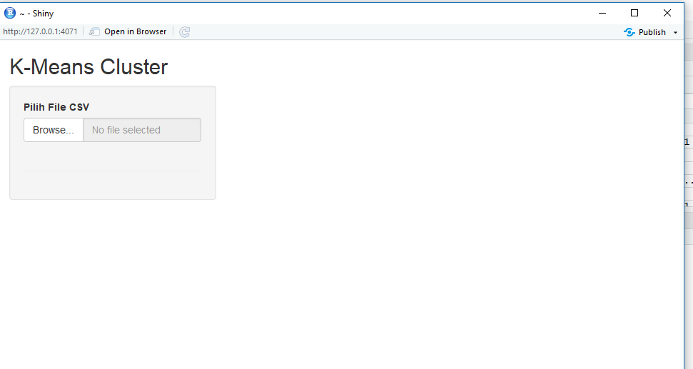

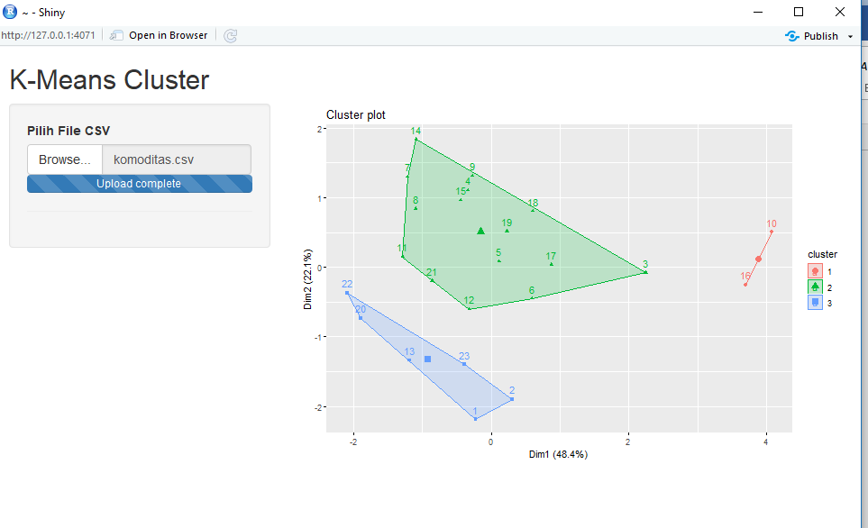

Tugas :Gunakan data yang menjadi tugas besar anda. Simpan dalam database dan gunakan shiny untuk membangun aplikasi menggunakan salah satu algoritma data mining

**Data Harga Pangan Indonesia**

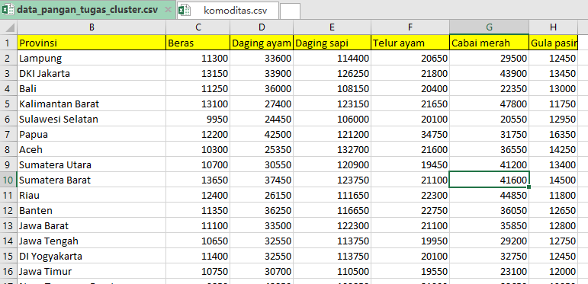

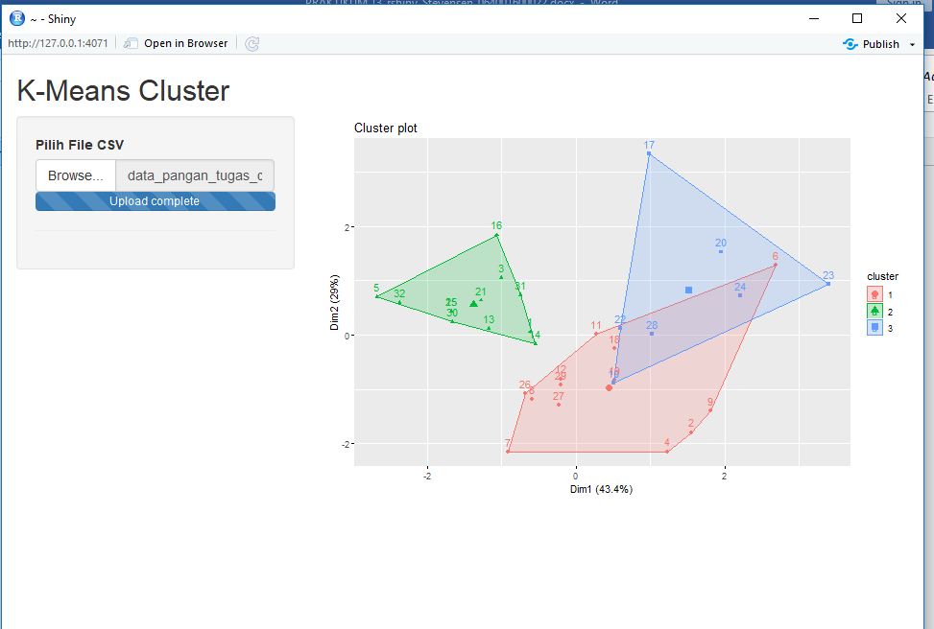

**References:**

<https://s3.amazonaws.com/assets.datacamp.com/production/course_4850/slides/Chapter1.pdf>